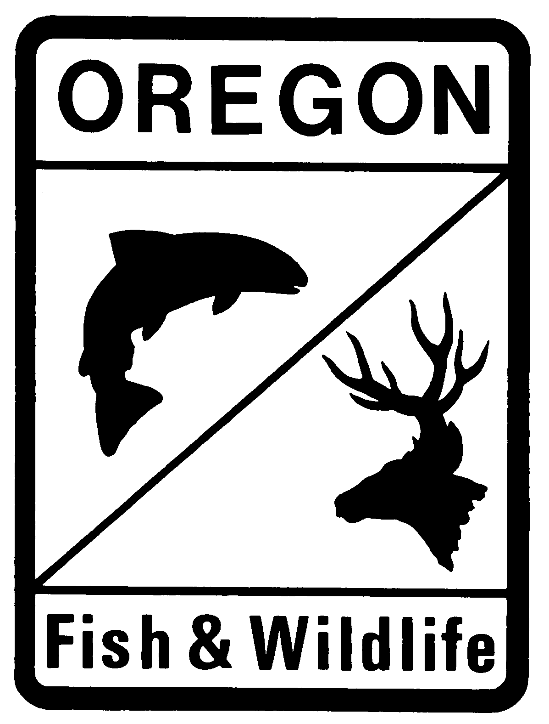
Oregon Department of Fish and Wildlife
Fish Passage Plan for Beaver Dam Analogue and Post Assist Log Structures
--- Expedited Plan Application ---

Project Name:
Stream Name:
Project Purpose:
Date of Fish Passage Submittal:
Date of Proposed Construction:

Applicant Information

Property Owner: Title:
Organization:
Address:
City: State: Zip:
E-Mail Address:

Signature: __________________________________________________ Date: _____________

Project Sponsor: Title:
Organization:
Address:
City: State: Zip:
E-Mail Address:

Signature: __________________________________________________ Date: _____________

Authorized Agent: Title:
Organization:
Address:
City: State: Zip:
E-Mail Address:

Signature: __________________________________________________ Date: _____________

Project Location

County:
Road Name:
River/Stream:
Tributary Of:
Basin:
Coordinates (NAD 83 in decimal degrees to at least 4 places):
Latitude: °N
Longitude: °W
Project Information
Fill in below, or attach a proposal containing the following information. Clarification and definitions are shown in the footnotes. Unlock the form or attach additional sheets as necessary.
Purpose, need and goals of the project
Describe the project purpose and need, restoration goals and intended outcomes and functions of the restoration structure(s) (i.e. beaver recruitment, channel bed aggradation, floodplain connectivity, grade control, streamflow duration, water table elevation, etc.) and how these goals are consistent with land use of project owner.

Project Reach
Include average measurements (ft) for the project reach.
Project reach length
Streambed slope (%)
Active channel width
Active channel height
Low terrace height
High terrace height
Floodplain width

Are beaver currently present at the project location? Yes No

Scope and Design of the Project
Description of the overall project plan, including the number of structures, how they are expected to function together, diameter and horizontal spacing of the untreated wood posts, height and density of the weaved materials, other materials that will be utilized, and source of materials (on/off site).

Describe how design and Construction Techniques are consistent with The Techniques described in the Beaver Restoration Guidebook (2018 version 2.01) and the Low-Tech Process-Based Restoration of Riverscapes. Electronic Links to these resources are located in footnotes below.
Describe and emphasize how structure(s) are hand-built, permeable, low-profile, temporary, made with organic untreated wood materials, mimic natural beaver dam functions and will be maintained to not become fish passage obstructions. Include method of installation, equipment that will be used and site access.

- Check box confirming project will be implemented consistent with guidebook and design manual (referenced above) and during appropriate in-water work windows (ODFW In-water Work Window Timing)
Water Management and Fish Exclusion Plan
What are the anticipated flows during construction? If stream de-watering is proposed, include a description of the methods that will be used to de-water and exclude fish from the work area. Fish salvage must be performed by a qualified person in possession of a valid Oregon Scientific Take Permit.

Monitoring, Reporting, and Maintenance
Monitoring and reporting on the effectiveness of fish passage through the project is required. Monitoring reports shall be completed by a qualified biologist or natural resources technician, and submitted to the ODFW District Fish Biologist by December 31 annually for a period of 3 years after completion of the project. The site shall be visited two times after the first winter during high and low stream flows, and one time annually for the following two years. Monitoring shall include visual observations, photos of representative structures, and a summary of how structures are performing with regards to fish passage. If monitoring indicates that fish passage is not being adequately provided, unless a beaver has assumed maintenance of the structure, the landowner/project sponsor is responsible for coordinating with ODFW and correcting any fish passage deficiencies.

Description of how the project will be maintained until desired effects are achieved.

Attachments & materials
Attach the following design drawings, sketches, maps and photos with the specified information identified. Emphasis on how projects will be implemented consistent with Guidebook or Design Manual identified in footnotes 10 & 11 are critical to the ODFW expedited review and approval.
-- Plan view or aerial Photo showing
- Location of proposed structures
- Location of treatment reaches
- Location of stream channel cross sections
- Active Channel width (ACW)
- Extent of current floodplain

-- Cross-Sections of Existing Stream Channel and Floodplain
- Representing reach type (configuration of ACW, low and high terraces)
- Shape of stream channel and floodplain
- Active Channel width and height
- Low/high terrace widths and heights

-- Photos
- Site
- Stream channel and banks
- Representative proposed BDA or PALS locations

Email complete application and requested attachments and materials to the local ODFW District Fish Biologist and cc Fish Passage Coordinator Greg.D.Apke@odfw.oregon.gov. Allow 2-3 weeks for application processing and email authorization notification from ODFW District Fish Biologist.

For additional information and assistance please contact Greg Apke, ODFW Statewide Fish Passage Program Leader at 503-947-6228. You can also contact the local ODFW District Fish Biologist or visit the ODFW Fish Passage Web Site (see below links).
ODFW Local Contacts
ODFW Fish Passage Requirements

Allow at least 2-3 weeks for processing prior to proposed construction. Implicit to an expedited and efficient ODFW review process is effective pre-project planning and coordination with ODFW District Fish Biologist.
The property owner/sponsor are ultimately responsible to ensure that the structures maintain fish passage over time. This party will monitor and maintain the project and are responsible for remedying the situation should the project become a fish passage barrier in the future. The approval will be issued to both the property owner and the project sponsor.
If different than above.
Active channel width is the stream width between the ordinary high water line elevation, or at the channel bankfull elevation if the ordinary high water lines are indeterminate.
Measure active channel height from the thalweg (lowest point) in the stream channel.
Low terrace is located below the active channel height, which represents the accessible floodplain height.
High terrace is located above the active channel height, which represents the confining floodplain.
Floodplain width is the distance between the banks of the high terrace, if present. Otherwise, use valley width.
Gap between the posts.
Pollock, M.M., G.M. Lewallen, K. Woodruff, C.E. Jordan and J.M. Castro (Editors) 2018. The Beaver Restoration Guidebook: Working with Beaver to Restore Streams, Wetlands, and Floodplains. Version 2.01. Online@: OFWO - Beaver Restoration
Wheaton J.M. et al. 2019 Low-Tech Process-Based Restoration of Riverscapes Design Manual Version 1.0 Riverscapes Restoration Design Manual

